Computer Systems
CFGS DAW

Computer Systems – Activities 1
UD 07. Windows Administration -Part 1 and 2-

Sergio García / Alfredo Oltra
sergio.garcia@ceedcv.es
alfredo.oltra@ceedcv.es
2022/2023
Versión:220725.1614

Licencia


Reconocimiento – NoComercial – CompartirIgual (by-nc-sa): No se permite un uso comercial de la obra original ni de las posibles obras derivadas, la distribución de las cuales se debe hacer con una licencia igual a la que regula la obra original.

Nomenclatura

A lo largo de este tema se utilizarán distintos símbolos para distinguir elementos importantes dentro del contenido. Estos símbolos son:

 Actividad opcional. Normalmente hace referencia a un contenido que se ha comentado en la documentación por encima o que no se ha hecho, pero es interesante que le alumno investigue y practique. Son tipos de actividades que no entran para examen

 Atención. Hace referencia a un tipo de actividad donde los alumnos suelen cometer equivocaciones.

UD07. Windows Administration -Part 1 and 2-
Activities

(1) Create an account called “miCompiExperto” with administrator profile and an account called “miCompiPeligroso” with normal user profile.

(2) Try to delete Windows folder with Account “miCompiPeligroso”. What happens?

(3) Configure Windows 10 to update manually. How can you search for updates with that configuration?

(4) Use Disk manager to shrink your disk. Use them to expand your disk again.

(5) Deactivate a device. What happens? Activate it again.

(6) Configure BitLocker to cipher a partition.

(7) Update Windows Defender and run a quick scan.

(8) Use msconfig to:
- Disable (and later enable) a service (for example Windows Audio).
- Disable (and later enable) a program that is run on Windows start.

(9) Using console:
- Create this data structure.
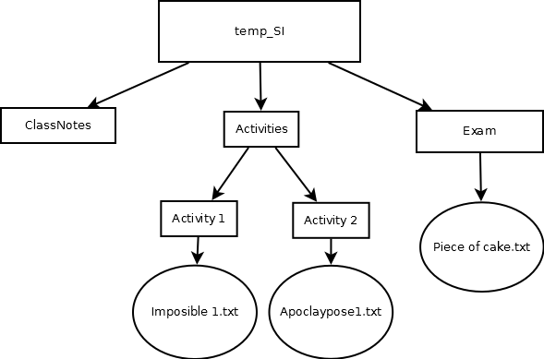
- Store in a file “c:\temp_SI\data.txt” the name of all files of the created structure.
- Store in a file “c:\temp_SI\dataWithA.txt” the name of all elements with an A in his name of the created structure.
- Order “data.txt” file by name in “data_ordered.txt” (relative path).
- Order “dataWithA.txt” file by name in “data_orderedWithA.txt” (relative path).
- Set attributes of “data.txt” (relative path) to hidden and read only.
- Set attributes of “dataWithA.txt” (relative path) to system.

